Alice and Bob talk on the phone. Bob has a mood that changes based on the weather. If it is sunny Bob is happy, but if it is rainy Bob is grumpy. However, Bob has bad days like everyone else so there are a few sunny days where Bob is sad and a few rainy days where Bob is happy.

Let’s say the probability that Bob is happy on a sunny day is 80% and 20% chance he is grumpy. Then, on a rainy day the probability of Bob being grumpy is 60% and the probability he is grumpy is 40%.

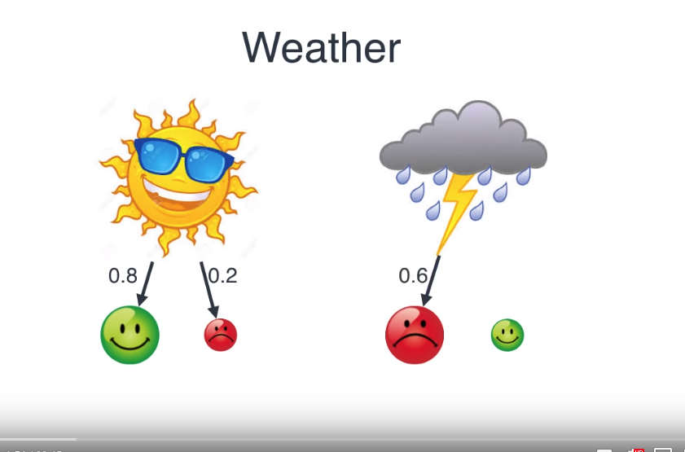
Let’s say we want to predict whether it is rainy or sunny where Bob lives based on his mood. We know that sometimes Bob is happy on rainy days and grumpy on sunny days, so it isn’t enough to know his mood. We need to know the weather and the probability that it is sunny or rainy.

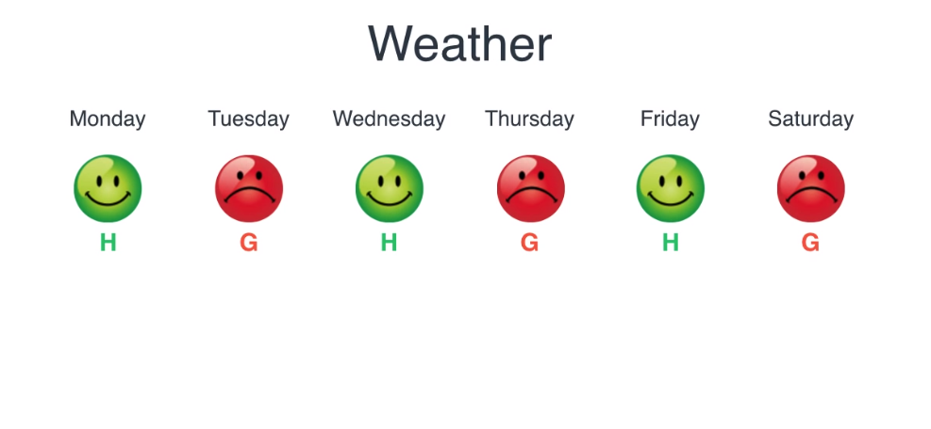

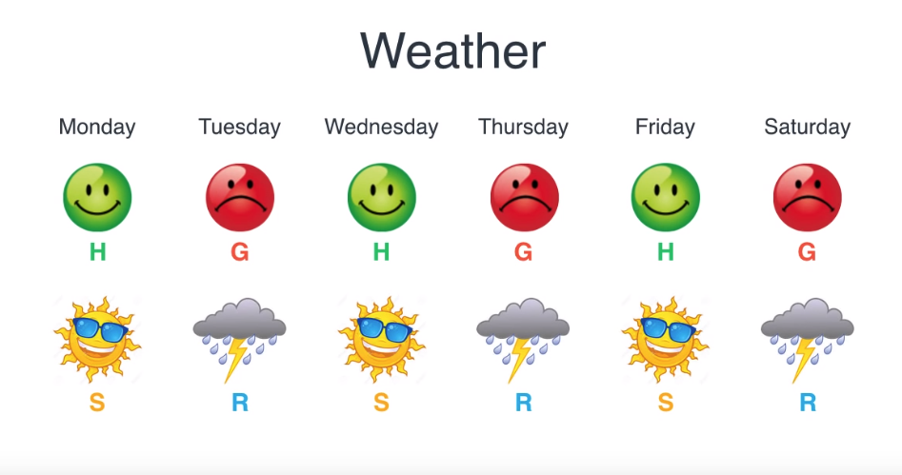

How likely is the sequence? The sequence is dependent upon not only whether Bob is happy or sad but also on the weather.

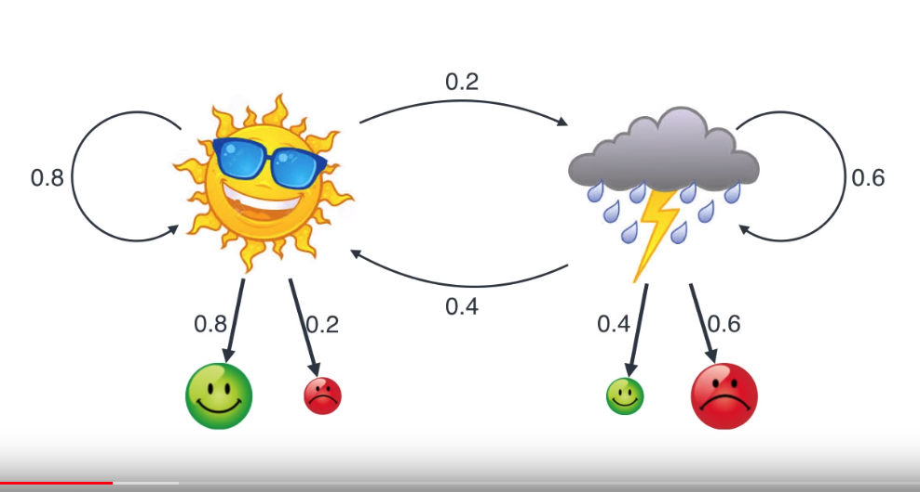
With the weather we can see that the probability of it raining tomorrow is 20% and the probability of it being rainy the day after that is 60%.

In the situation above we have the observations, which are Bob’s moods. Then we have the hidden states which are the weather. They are hidden because we don’t see the weather directly but make inferences about the weather based on Bob’s mood.

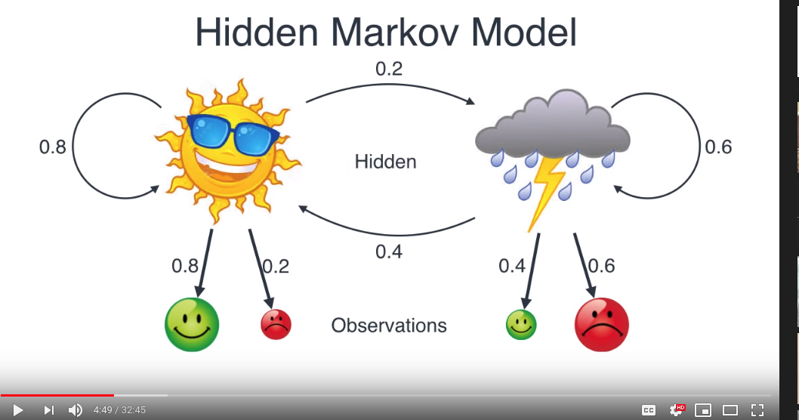

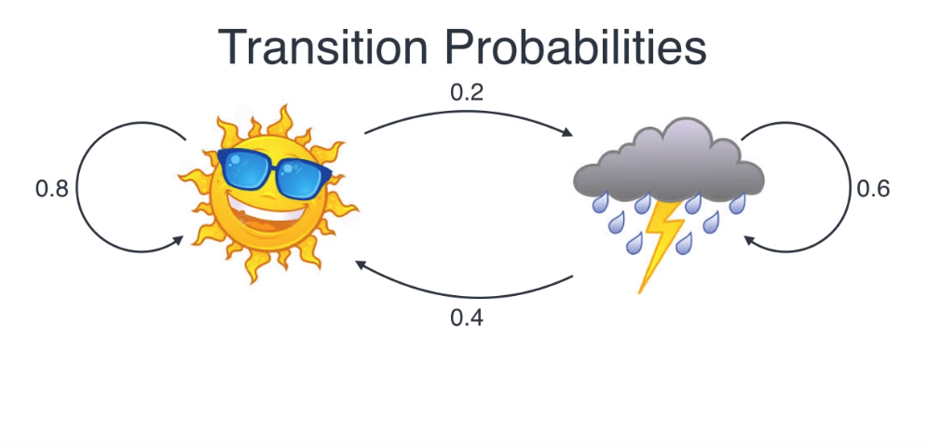
Transition properties are called such because they represent the probabilities of going (transitioning) from one state to another.

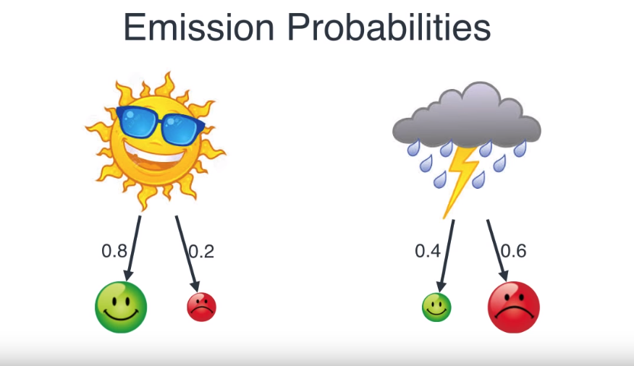
The emission probability is the probability of seeing an event (grumpy) based on a state (rainy).

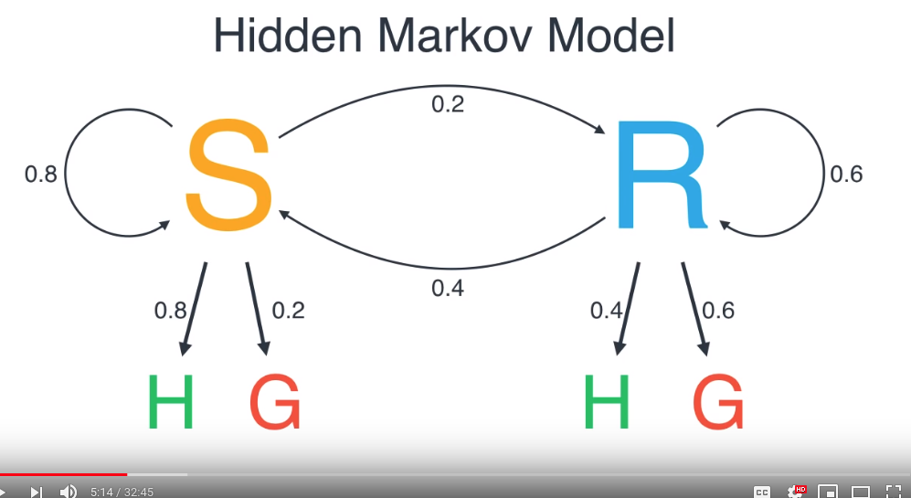
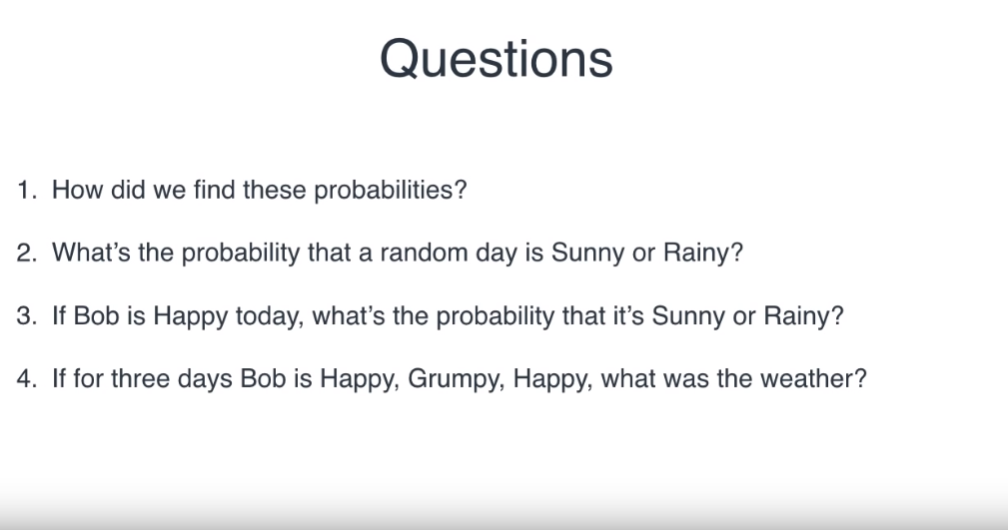

The number of days where it was sunny after a sunny day is 8. The number of days where it was sunny then rainy was 2.

p(sun following sin) is 8/10 and p(cloudy following sun) is 2/10 and so on.

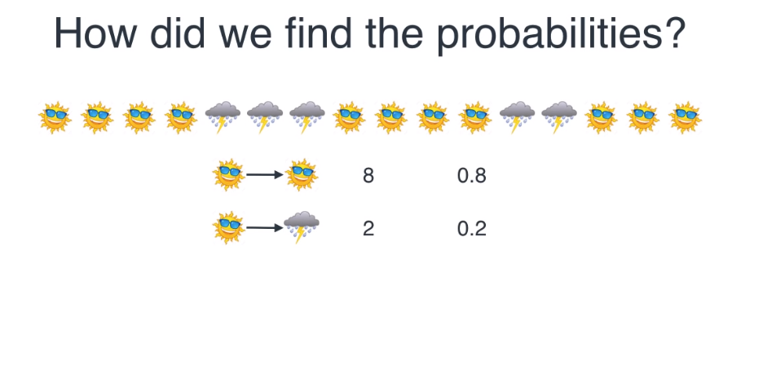
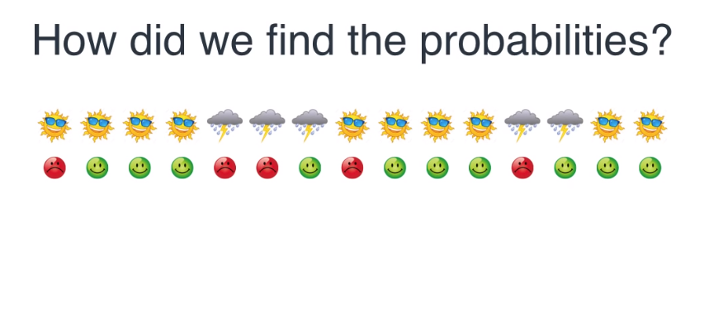
Emission probabilities:

Sunny and happy: 8/10.
Sunny and sad: 2/10.
Rainy and happy: 2/5.
Rainy and sad: 3/5.

What’s the probability that a random day is sunny or rainy: 100%
Rainy: 5/15
Sunny: 10/15

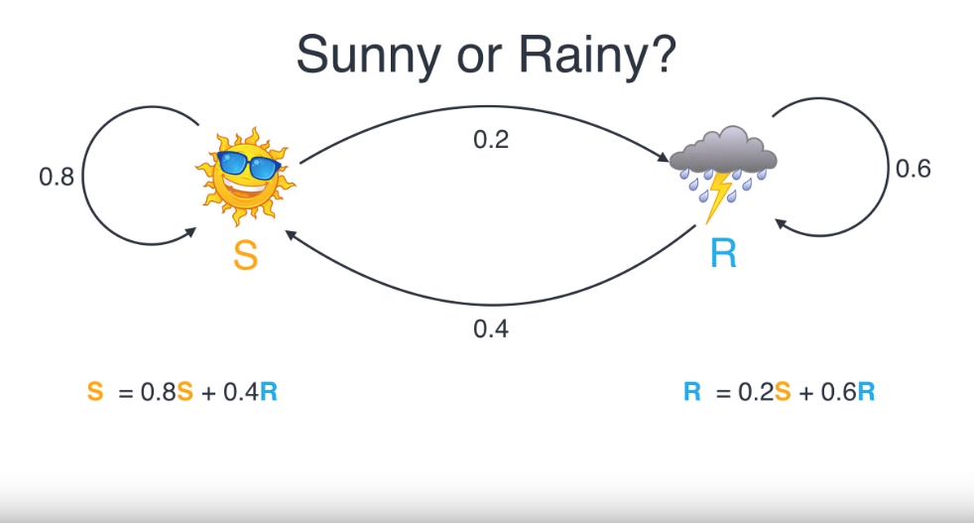
System of two equations.
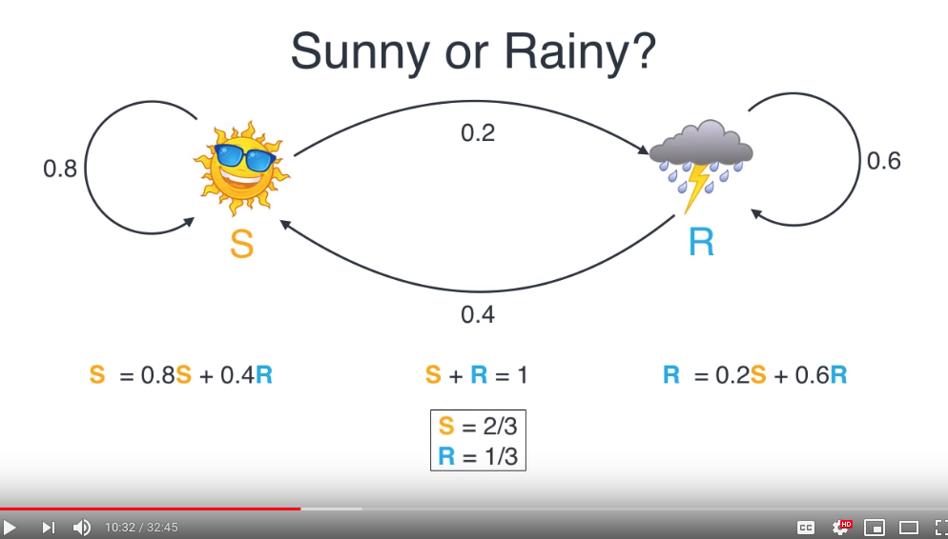
Given that it bob is happy what is the probability it is rainy or sunny?
The answer to this question is Bayes Theorem.

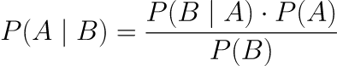

=events=probability of A given B is true=probability of B given A is true=the independent probabilities of A and B

P(Bob Happy) = 10/15
P(Sunny) = 10/15

P(Bob Happy | Sunny) = 8/10 (Posterior Probabilities)
P(Bob Grumpy | Sunny) = 2/10 (Posterior Probabilities)
P(Bob Happy | Rainy) = 2/10 (Posterior Probabilities)
P(Bob Grumpy | Rainy) = 8/10 (Posterior Probabilities)

Markov Chains-- a Sequence:

If for three days we record Bob’s mood as: Happy, Grumpy, Happy, what is the weather?

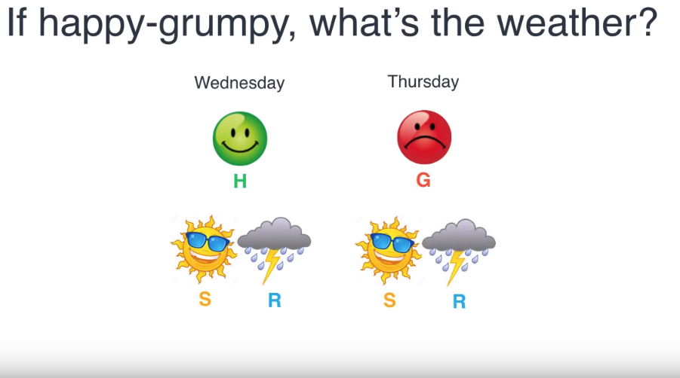
Given what we know, we have four possible transitions:

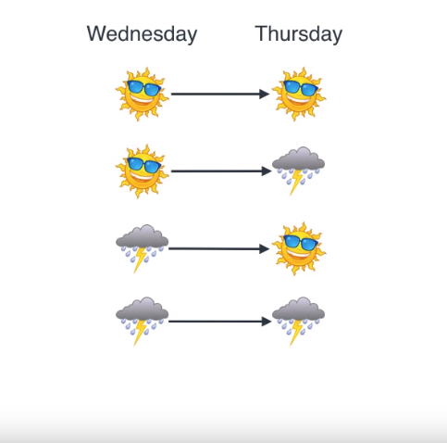

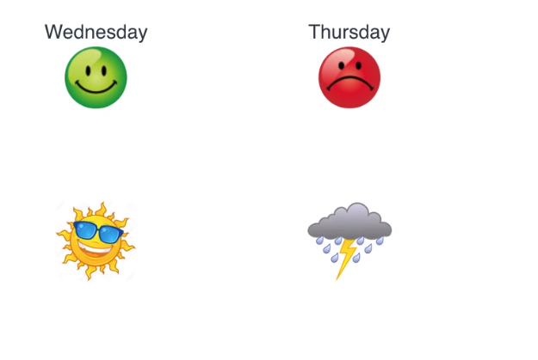

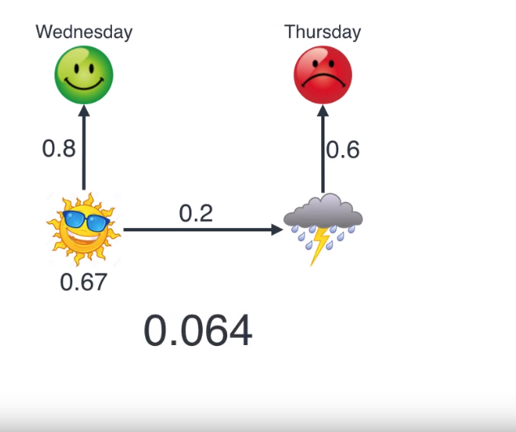
Conditional probability:

.8 *.67 * .2 * .6 = 0.06432

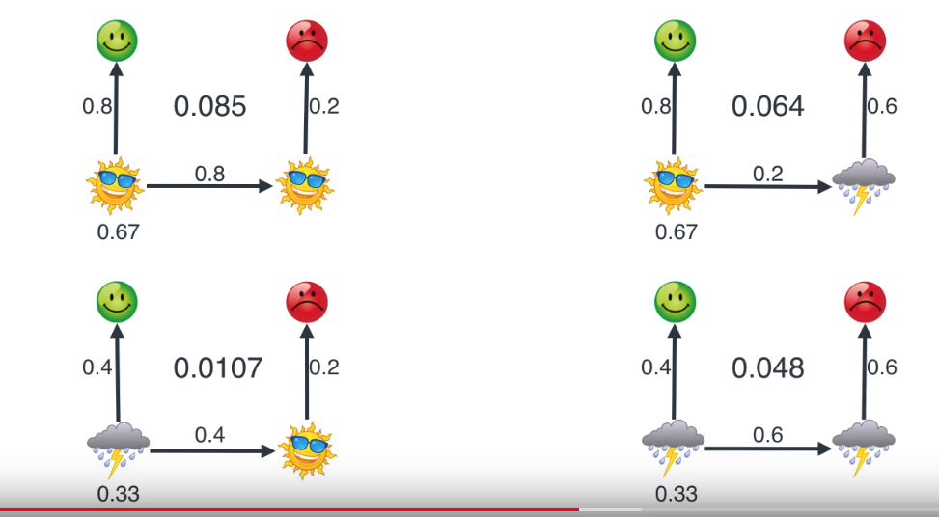
If happy then grumpy what is the weather? We have calculated the likelihood for the four possible transitions and we choose the highest probability. This is called the maximum likelihood. We pick the model sunny → sunny because it is the most likely.

The number of transitions is modeled by: n^p where n is the possible number of choices and p is the period. So for rainy or sunny over two days it is 2^2 or 4 transitions. For 3 days its 2^3 or 8 transitions.

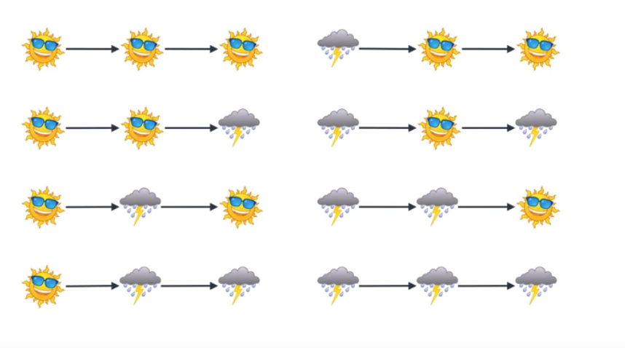

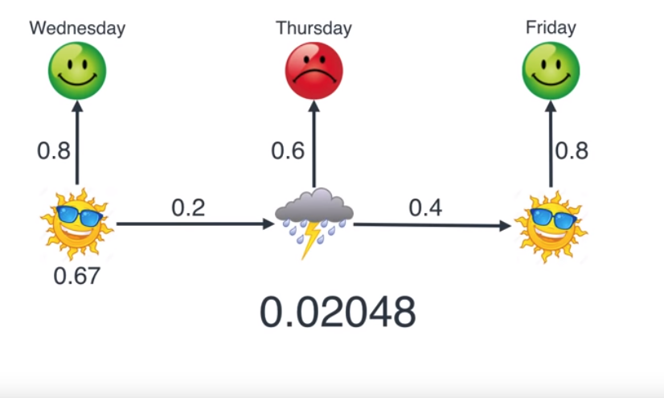
AS we go up in the week range we start to get computationally complicated. We can use a hidden Markov model and Viterbi algorithm to do this more efficiently.

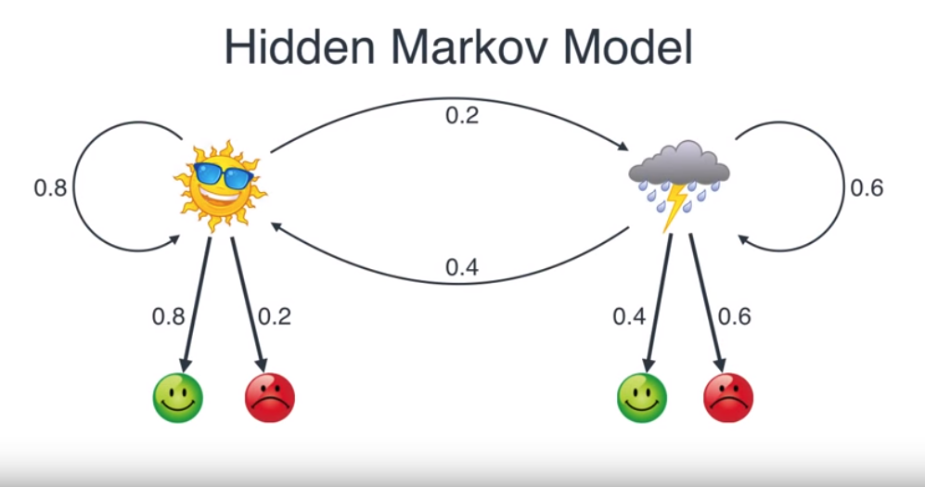

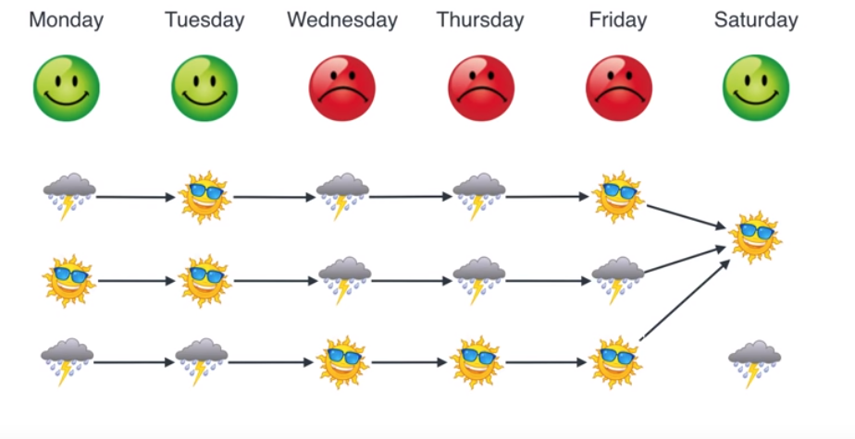

Lots of scenarios that could have lead to Saturday being a sunny and happy day for bob but we only care about the highest probability scenario. So we look at the two paths and pick the most likely one. Path 1 probability times the probability of Bob being happy on a sunny day vs path ii probability times the probability of Bob being happy on a rainy day.

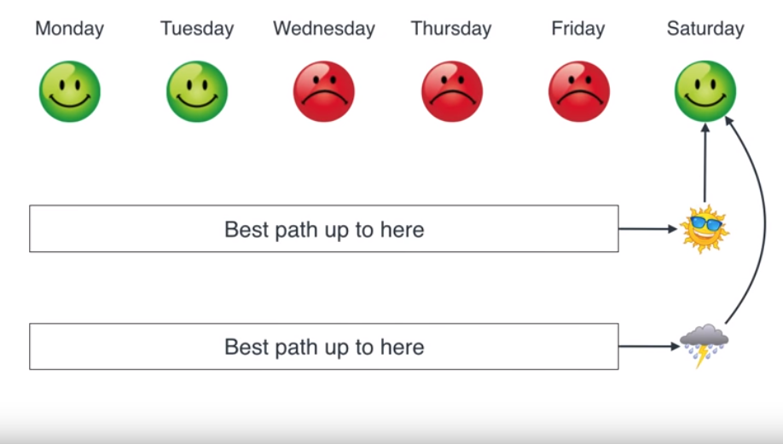

Then:

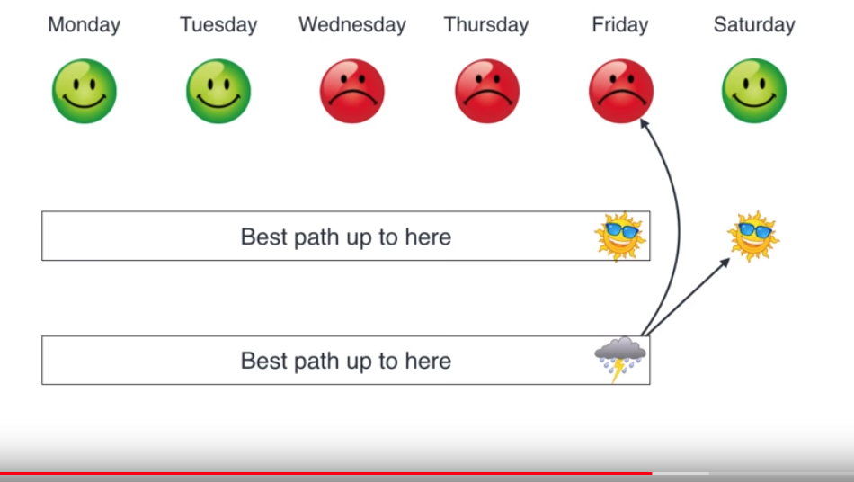
The Viterbi algorithm compares sets of outcome rather than every possible sequence of outcomes. The Viterbi algorithm finds maximum probability for these pairs rather than for all the possible sequences.

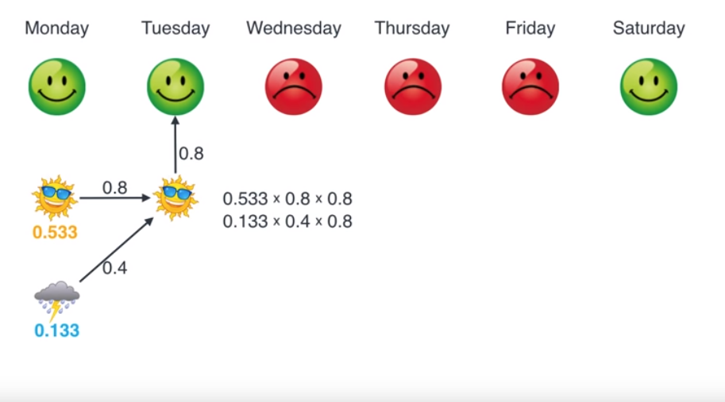
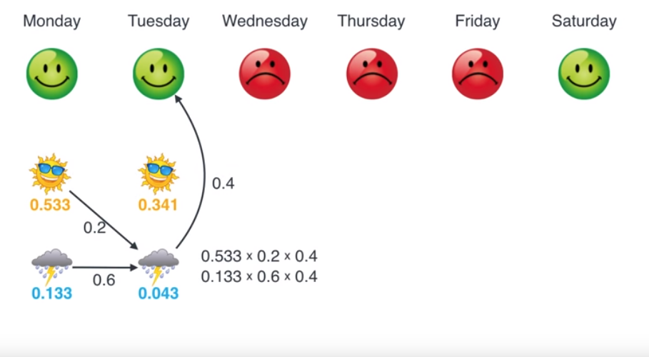
Choose most likely on Tuesday and so on… This leads to the most likely path.

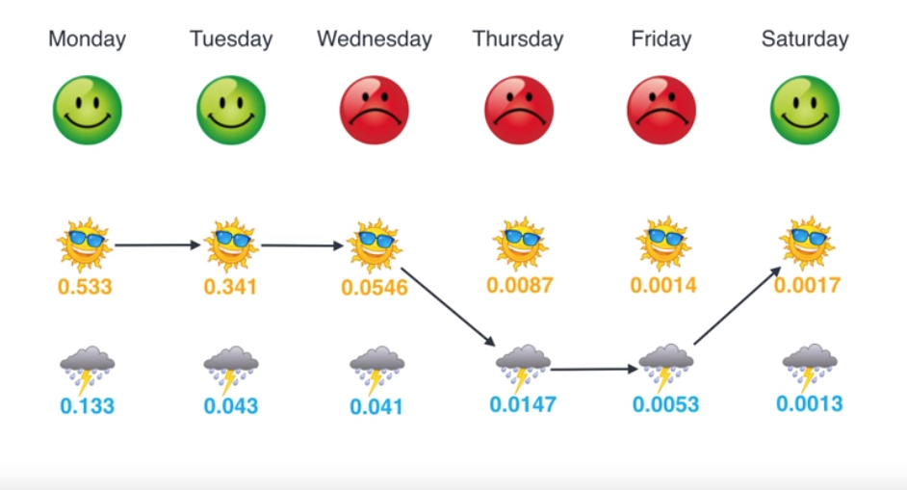
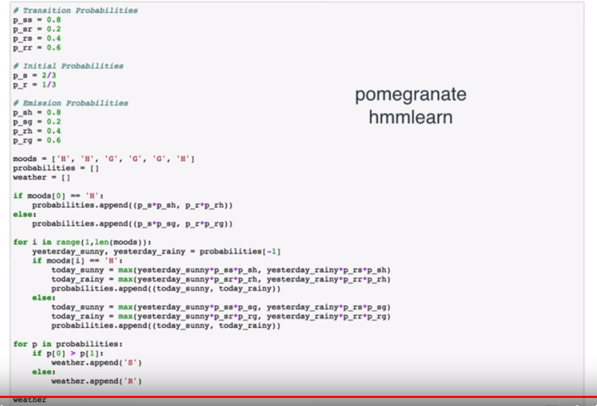

If we don’t know the transition probabilities we can use




